**Car Wash Management System**



**Session: 2022**

**Submitted by:**

**Wali Muhammad 2021-SE-39**

**Muhammad Mubashir 2022-SE-46**

**Submitted to:**

**Dr. Zeeshan Ramzan**

Department of Computer Science,

**University of Engineering and Technology, New Campus Lahore**

Table of Contents

INTRODUCTION 3

Project Title 3

Objectives 3

Functions 3

Architecture 4

Reasons: 4

Use Cases 5

Primary Actor: 5

Use Cases Table: 5

UML DIAGRAMS 20

Use Case Diagram 20

Class Diagram 21

Object Diagram 22

Sequence Diagram 23

Collaboration Diagram 39

Activity Diagram 44

State Machine Diagram 62

Component Diagram 67

Package Diagram 68

Deployment Diagram 68

# INTRODUCTION

This Document is the comprehensive overview of Our project car wash management system. This document will talk about all the services for the cars their details, customers details, employee details and details of the business lost and add.

## Project Title

Car Wash Management System

## Objectives

The objective of this Project is to provide the people with the efficient car wash services, manage their employee very well, record their customers correct and provide them best services with best practice of new technologies and methods. The aim is to give the customers a better satisfaction about your services by providing them best serve, and also aim include to increase growth of your business.

## Functions

Functions that will include are:

1. Vehicle Management
   * Add vehicle to system
   * Remove vehicle
   * Update information’s of the vehicle in system
2. Customer management
   * Can handle customer details add customer
   * Delete customer
   * Update a customer info
3. Employee management
   * Handle employee info add new employee
   * Remove existing employee
   * Update info of an existing employee
4. Services management
   * Add services to system
   * Delete an existing service
   * Update services
5. Sales Management

* Calculate Revenue
* Calculate Profit
* Store Revenue and Profit in Database

1. Print Receipt
2. Data Authentications
   * Ensure data Validation and security

## Architecture

Our project based on the Client server architecture. Admin acts as a client and interacts with server to manage the employees, services, vehicles and customers.

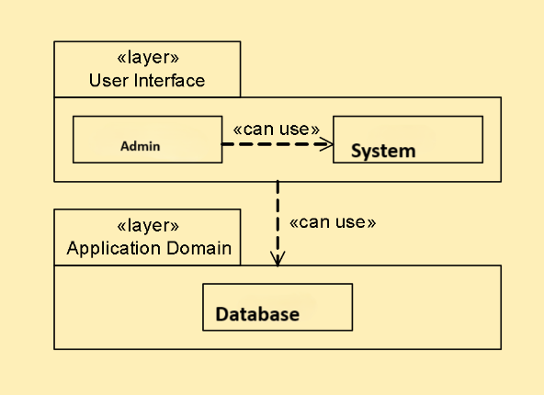

## Reasons:

This architecture offers many advantages that suits our project management and its best working here are some given below:

1. Scalability

By this we can scale the client (interface) to add more clients or server to manage it

1. Centralized data management

Means all clients (user interface) can access the same data ensuring consistency and integrity

1. Improved Security

Centralized data management on server allow to better security implementations

1. Easier maintenance

Separating the server and client side it will make maintenance easier

1. Platform independence

Client server architecture allow the app for platform independence

1. Concurrency and load management

Server can handle concurrency and can distribute the work load efficiently

## Use Cases

## Primary Actor:

1. Admin

## Use Cases Table:

|  |  |
| --- | --- |
| **UC-1** | Sign In |
| **UC-2** | Add Employee |
| **UC-3** | Add Customer |
| **UC-4** | Add Services |
| **UC-5** | Add Vehicle |
| **UC-6** | Update Employee Info |
| **UC-7** | Update Customer Info |
| **UC-8** | Update Service Info |
| **UC-9** | Update Vehicle Info |
| **UC-10** | Delete Existing Employee |
| **UC-11** | Delete Existing Customer |
| **UC-12** | Delete Existing Service |
| **UC-13** | Delete Existing Vehicle |
| **UC-14** | View Report |
| **UC-15** | Calculate Sales Profit |
| **UC-16** | Sing Up |
| **UC-17** | Print Bill |
| **UC-18** | Logout |

**UC-1: Sign In**

|  |  |  |
| --- | --- | --- |
| **Name** | **Sign In** | |
| **Actors** | **Admins** | |
| **Goal** | **As a Padmini want to Sign In.** | |
| **Trigger** | **Click on Sign in Button.** | |
| **Pre-Condition** | 1. **Admin/ Admin must provide username.** 2. **Admin/ Admin must provide password.** | |
| **Post-Condition** | **Admin/ Admin successfully signed in.** | |
| **Basic Flow** | **Enter username and password and get signed in.** | |
| **Exceptions** | **Exception** | **Solution** |
| 1. **Admin/ Admin forgot the password** | **2.If Admin/ Admin Forgot the Password, then give him an opportunity of accessing it by forgot password option.** |
| **Quality attribute** | **Admin is authorized by Admin** | |

**UC-2: Add Employee**

|  |  |  |
| --- | --- | --- |
| **Name** | **Add Employee** | |
| **Actors** | **Admin** | |
| **Goal** | **As an Admin I want to Add Employee** | |
| **Trigger** | **Click on Add Admin Button.** | |
| **Pre-Condition** | 1. **Admin must be on Admin panel.** 2. **Admin Must be Signed In.** | |
| **Post-Condition** | **Admin successfully Added.** | |
| **Basic Flow** | 1. **Admin comes on Employee Panel.** 2. **Press Add Employee.** 3. **Admin will provide necessary details of admin**   **- age**  **- name**  **- phone number**  **- email address**  **- role**  **- salary**  **Press Confirm Employee Addition.** | |
| **Exceptions** | **Exception** | **Solution** |
| 1. **Internet is off.** | 1. **Make internet in running (on) state, if it is off.** |
| 1. **Admin must be on Employee panel.** | **2.If Admin isn’t on Employee Panel, He must open it.** |
| 1. **Admin isn’t signed in** | **3.Admin Must be signed in first.** |
| **Quality attribute** | **N/A** | |

**UC-3: Add Customer**

|  |  |  |
| --- | --- | --- |
| **Name** | **Add Customer** | |
| **Actors** | **Admin** | |
| **Goal** | **As an Admin I want to Add Customer** | |
| **Trigger** | **Click on Add Medicines.** | |
| **Pre-Condition** | 1. **Admin must be on Add Customer Portal** 2. **Admin must be signed in.** | |
| **Post-Condition** | **Customer Added Successfully** | |
| **Basic Flow** | 1. **Admin comes on the Add Customer Page.** 2. **Provide Credentials and click sign in** 3. **Admin will provide following attributes of medicine:** 4. **Press Add Medicine.** | |
| **Exceptions** | **Exception** | **Solution** |
| 1. **Admin isn’t on Add Customer Portal** | **2.Admin must be on Add Customer Portal** |
| 1. **Admin isn’t signed in.** | **3.Admin must be signed in.** |
| **Quality Attributes** | **N/A** | |

**UC-4: Add Service**

|  |  |  |
| --- | --- | --- |
| **Name** | **Add Service** | |
| **Actors** | **Admin** | |
| **Goal** | **As an Admin I want to Add Service** | |
| **Trigger** | **Click on Add Service** | |
| **Pre-Condition** | 1. **Admin must be signed in.** 2. **Admin must be on Add Service** | |
| **Post-Condition** | **Bill is printed successfully.** | |
| **Basic Flow** | 1. **Admin comes on the Sign In page.** 2. **Enter correct credentials for signing in.** 3. **After signing in admin clicks add to virtual cart.** 4. **For adding in virtual cart, the admin search for medicine by its name and enter quantity.** 5. **Press confirm cart.** 6. **Press pint bill.** | |
| **Exceptions** | **Exception** | **Solution** |
| 1. **Admin provided wrong credentials** | **3.On providing invalid credentials, student must be provided with a path for accessing password by forgot password key.** |
| 1. **Admin isn’t signed in.** | **4.Admin must be signed in first.** |
| 1. **Admin isn’t on Add Service.** | **5.Admin must be on Add service.** |
|  |  |
| **Quality attribute** | **N/A** | |

**UC-5: Add Vehicle**

|  |  |  |
| --- | --- | --- |
| **Name** | **Add Vehicle** | |
| **Actors** | **Admin** | |
| **Goal** | **As an Admin I want to Add Vehicle** | |
| **Trigger** | **Click on Add Vehicle** | |
| **Pre-Condition** | 1. **Admin must be on Add Vehicle Admin must be signed in.** | |
| **Post-Condition** | **Added Vehicle Successfully** | |
| **Basic Flow** | 1. **Admin comes on the Add Vehicle Page.** 2. **Provide Credentials and click sign in** 3. **Select Add Vehicle Option.** 4. **Admin will provide Vehicle Credentials.** 5. **Press Update Medicine.** | |
| **Exceptions** | **Exception** | **Solution** |
| 1. **Admin isn’t on Add Vehicle** | **2.Admin must be on Add Vehicle Portal** |
| 1. **Admin isn’t signed in.** | **3.Admin must be signed in.** |
|  |  |
| **Quality attribute** | **N/A** | |

**UC-6: Update Employee Info**

|  |  |  |
| --- | --- | --- |
| **Name** | **Update Employee Info** | |
| **Actors** | **Admin** | |
| **Goal** | **As an Admin I want to Update Employee Info** | |
| **Trigger** | **Click on Update Employee Data.** | |
| **Pre-Condition** | 1. **Admin must be signed in.** | |
| **Basic Flow** | 1. **Admin comes on Employee Panel.** 2. **Press Update Employee.** 3. **Admin will provide necessary details of admin**   **- age**  **- name**  **- phone number**  **- email address**  **- role**  **- salary**  **Press Confirm Employee Update.** | |
| **Post-Condition** | **Admin successfully Update Employee Info** | |
| **Exceptions** | **Exception** | **Solution** |
| 1. **Admin isn’t signed In.** | 1. **2. Admin must be signed in.** |
| 1. **Admin isn’t on Employee Panel.** | **2. Admin must be on Employee Panel.** |
| **Quality attribute** | **N/A** | |

**UC-7: Update Customer Info**

|  |  |  |
| --- | --- | --- |
| **Name** | **Update Customer Info** | |
| **Actors** | **Admin** | |
| **Goal** | **As an Admin I want to Update Customer Info** | |
| **Trigger** | **Click on Update Customer Data.** | |
| **Pre-Condition** | 1. **Admin must be signed in.** | |
| **Basic Flow** | 1. **Admin comes on Customer Panel.** 2. **Press Update Customer.** 3. **Admin will provide necessary details of Customer**   **- age**  **- name**  **- phone number**  **- email address**  **- role**  **- salary**  **Press Confirm Customer Update.** | |
| **Post-Condition** | **Admin successfully Update Employee Info** | |
| **Exceptions** | **Exception** | **Solution** |
| 1. **Admin isn’t signed In.** | 1. **2. Admin must be signed in.** |
| 1. **Admin isn’t on Employee Panel.** | **2. Admin must be on Employee Panel.** |
| **Quality attribute** | **N/A** | |

**UC-8: Update Service Info**

|  |  |  |
| --- | --- | --- |
| **Name** | **Update Service Info** | |
| **Actors** | **Admin** | |
| **Goal** | **As an Admin I want to Update Service Info** | |
| **Trigger** | **Click on Update Service Data.** | |
| **Pre-Condition** | 1. **Admin must be signed in.** | |
| **Basic Flow** | 1. **Admin comes on Employee Panel.** 2. **Press Update Employee.** 3. **Admin will provide necessary details of admin**   **- age**  **- name**  **- phone number**  **- email address**  **- role**  **- salary**  **Press Confirm Employee Update.** | |
| **Post-Condition** | **Admin successfully Update Employee Info** | |
| **Exceptions** | **Exception** | **Solution** |
| 1. **Admin isn’t signed In.** | 1. **2. Admin must be signed in.** |
| 1. **Admin isn’t on Employee Panel.** | **2. Admin must be on Employee Panel.** |
| **Quality attribute** | **N/A** | |

**UC-9: Update Vehicle Info**

|  |  |  |
| --- | --- | --- |
| **Name** | **Update Employee Info** | |
| **Actors** | **Admin** | |
| **Goal** | **As an Admin I want to Update Employee Info** | |
| **Trigger** | **Click on View Admins Data.** | |
| **Pre-Condition** | 1. **Admin must be signed in.** | |
| **Basic Flow** | 1. **Admin comes on Employee Panel.** 2. **Press Update Employee.** 3. **Admin will provide necessary details of admin**   **- age**  **- name**  **- phone number**  **- email address**  **- role**  **- salary**  **Press Confirm Employee Update.** | |
| **Post-Condition** | **Admin successfully Update Employee Info** | |
| **Exceptions** | **Exception** | **Solution** |
| 1. **Admin isn’t signed In.** | 1. **2. Admin must be signed in.** |
| 1. **Admin isn’t on Employee Panel.** | **2. Admin must be on Employee Panel.** |
| **Quality attribute** | **N/A** | |

**UC-10: Delete Existing Employee**

|  |  |  |
| --- | --- | --- |
| **Name** | **Delete Existing Employee** | |
| **Actors** | **Admin** | |
| **Goal** | **The admin wants to Delete Existing Employee.** | |
| **Trigger** | **Click on Delete Existing Employee.** | |
| **Pre-Condition** | 1. **Internet must be turned on.**   **2. Admin must be signed in.** | |
| **Post-Condition** | **The admin successfully Delete Existing Employee** | |
| **Basic Flow** | 1. **Provide correct credentials for signing in.** 2. **Admin opens Employee Portal.** 3. **Click on Print Delete Employee button of existing Employee.** 4. **Employee Deleted.** | |
| **Exception** | 1. **Admin isn’t signed In.** | **2. Admin signed in.** |
| **Quality attribute** | **N/A** | |

**UC-11: Delete Existing Customer**

|  |  |  |
| --- | --- | --- |
| **Name** | **Delete Existing Employee** | |
| **Actors** | **Admin** | |
| **Goal** | **The admin wants to Delete Existing Employee.** | |
| **Trigger** | **Click on Delete Existing Employee.** | |
| **Pre-Condition** | **2. Admin must be signed in.** | |
| **Post-Condition** | **The admin successfully Delete Existing Employee** | |
| **Basic Flow** | 1. **Provide correct credentials for signing in.** 2. **Admin opens Employee Portal.** 3. **Click on Print Delete Employee button of existing Employee.** 4. **Employee Deleted.** | |
| **Exception** | 1. **Admin isn’t signed In.** | **2. Admin signed in.** |
| **Quality attribute** | **N/A** | |

**UC-12: Delete Existing Service**

|  |  |  |
| --- | --- | --- |
| **Name** | **Delete Existing Employee** | |
| **Actors** | **Admin** | |
| **Goal** | **The admin wants to Delete Existing Employee.** | |
| **Trigger** | **Click on Delete Existing Employee.** | |
| **Pre-Condition** | **2. Admin must be signed in.** | |
| **Post-Condition** | **The admin successfully Delete Existing Employee** | |
| **Basic Flow** | 1. **Provide correct credentials for signing in.** 2. **Admin opens Employee Portal.** 3. **Click on Print Delete Employee button of existing Employee.** 4. **Employee Deleted.** | |
| **Exception** | 1. **Admin isn’t signed In.** | **2. Admin signed in.** |
| **Quality attribute** | **N/A** | |

**UC-13: Delete Existing Vehicle**

|  |  |  |
| --- | --- | --- |
| **Name** | **Delete Existing Employee** | |
| **Actors** | **Admin** | |
| **Goal** | **The admin wants to Delete Existing Employee.** | |
| **Trigger** | **Click on Delete Existing Employee.** | |
| **Pre-Condition** | **2. Admin must be signed in.** | |
| **Post-Condition** | **The admin successfully Delete Existing Employee** | |
| **Basic Flow** | 1. **Provide correct credentials for signing in.** 2. **Admin opens Employee Portal.** 3. **Click on Print Delete Employee button of existing Employee.** 4. **Employee Deleted.** | |
| **Exception** | 1. **Admin isn’t signed In.** | 1. **Admin signed in.** |
| **Quality attribute** | **N/A** | |

**UC-14: View Report**

|  |  |  |
| --- | --- | --- |
| **Name** | **View Report** | |
| **Actors** | **Admin** | |
| **Goal** | **The admin wants to View Report.** | |
| **Trigger** | **Click on View Report** | |
| **Pre-Condition** | **2. Admin must be signed in.** | |
| **Post-Condition** | **The admin successfully View Report** | |
| **Basic Flow** | 1. **Provide correct credentials for signing in.** 2. **After signing in click on Print Sold Medicines Report.** | |
| **Exception** | 1. **Admin isn’t signed In.** | **2. Admin signed in.** |
| **Quality attribute** | **Admin can view the report of different dates** | |

**UC-15: Calculate Sales Profit**

|  |  |  |
| --- | --- | --- |
| **Name** | **Calculate Sales Profit** | |
| **Actors** | **Admin** | |
| **Goal** | **The admin wants to Calculate Sales Profit** | |
| **Trigger** | **Click on Print Sold Medicines Report.** | |
| **Pre-Condition** | **2. Admin must be signed in.** | |
| **Post-Condition** | **The admin successfully Calculate Sales Profit.** | |
| **Basic Flow** | 1. **Provide correct credentials for signing in.** 2. **After signing in click on setting portal.** 3. **Then click on calculate profit.** 4. **Calculate Sales Profit successfully** | |
| **Exception** | 1. **Admin isn’t signed In.** | **2. Admin signed in.** |
| **Quality attribute** | **Admin can store this in database** | |

**UC-16: Sign Up**

|  |  |  |
| --- | --- | --- |
| **Name** | **Sign Up** | |
| **Actors** | **Admins** | |
| **Goal** | **As an admin want to Sign Up.** | |
| **Trigger** | **Click on Sign Up Button.** | |
| **Pre-Condition** | 1. **Admin/ Admin must provide username.** 2. **Admin/ Admin must provide password.** | |
| **Post-Condition** | **Admin/ Admin successfully signed up.** | |
| **Basic Flow** | **Enter username and password and get signed up.** | |
| **Exceptions** | **Exception**  **N/A** | **Solution** |
| **Quality attribute** | **N/A** | |

**UC-17: Print Bill**

|  |  |  |
| --- | --- | --- |
| **Name** | **Print Bill** | |
| **Actors** | **Admin** | |
| **Goal** | **The admin wants to Print Bill** | |
| **Trigger** | **Click on Print Bill** | |
| **Pre-Condition** | **2. Admin must be signed in.** | |
| **Post-Condition** | **The admin successfully Print Bill** | |
| **Basic Flow** | 1. **Admin opens Admin Portal.** 2. **Provide correct credentials for signing in.** 3. **After signing in click on Print Bill** | |
| **Exception** | 1. **Admin isn’t signed In.** | **2. Admin signed in.** |
| **Quality attribute** | **N/A** | |

**UC-18: Logout**

|  |  |  |
| --- | --- | --- |
| **Name** | **Logout** | |
| **Actors** | **Admin** | |
| **Goal** | **The admin wants to Logout from system.** | |
| **Trigger** | **Click on Logout** | |
| **Pre-Condition** | **2. Admin must be signed in.** | |
| **Post-Condition** | **The admin successfully Logout** | |
| **Basic Flow** | 1. **Admin opens Admin Portal.** 2. **Provide correct credentials for signing in.** 3. **After signing in click on Logout** | |
| **Exception** | 1. **Admin isn’t signed In.** | **2. Admin signed in.** |
| **Quality attribute** | **N/A** | |

# UML DIAGRAMS

## Use Case Diagram

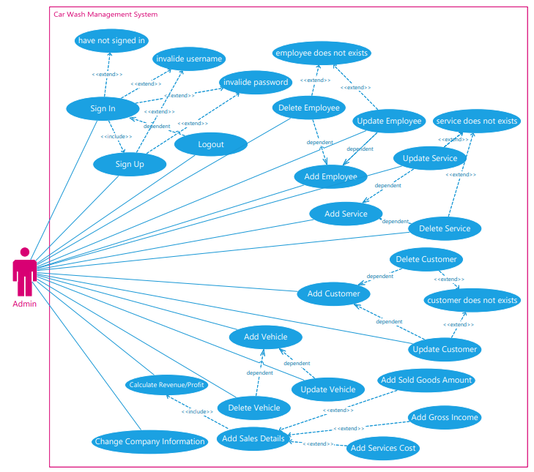

## Class Diagram

## Object Diagram

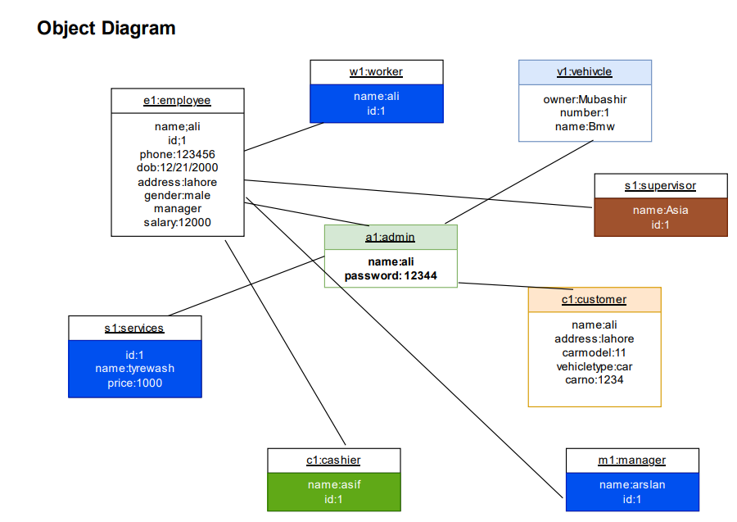

## Sequence Diagram

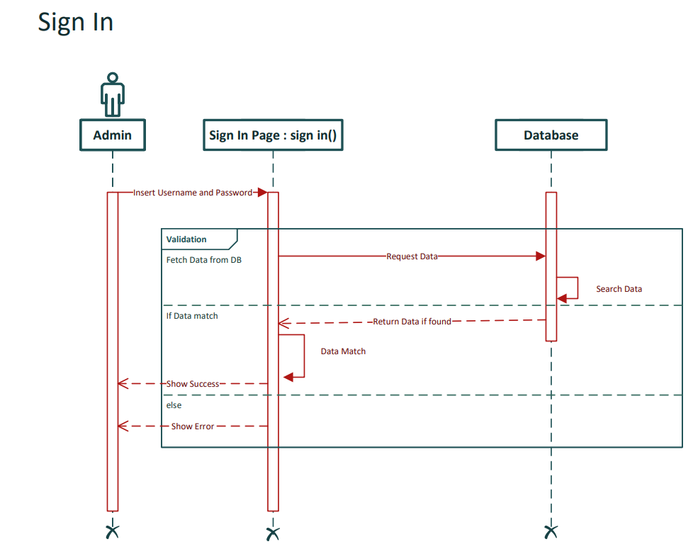

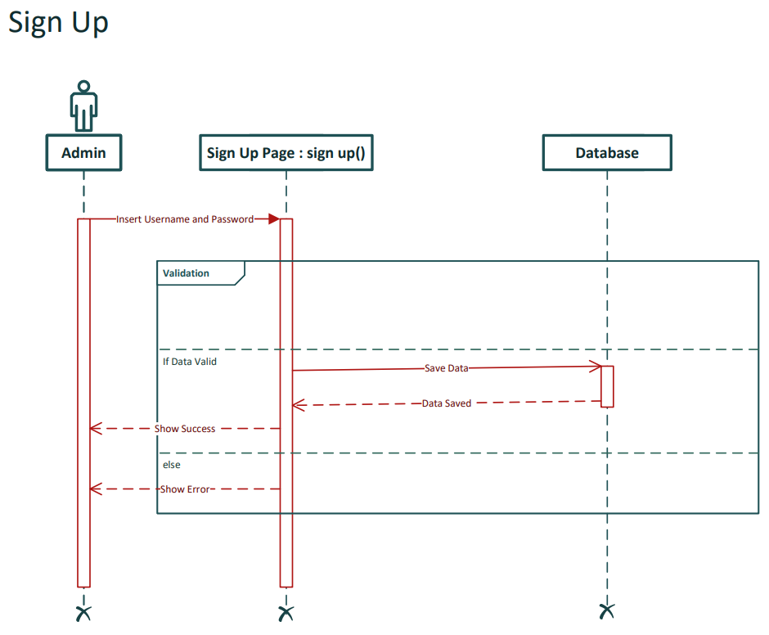

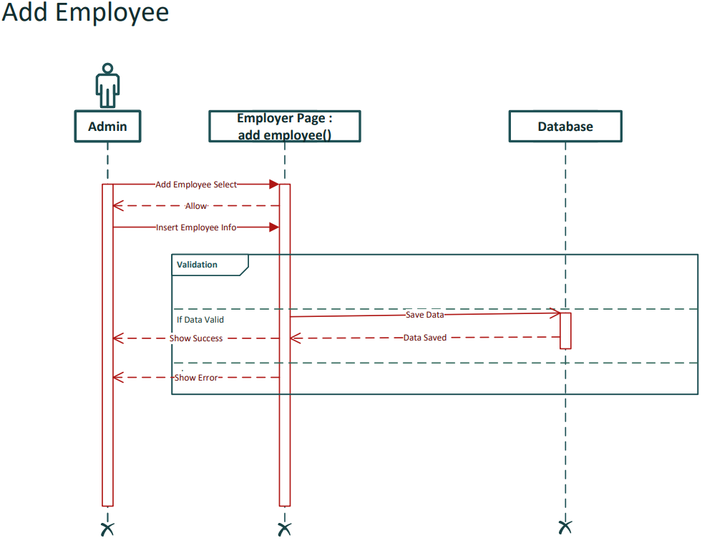

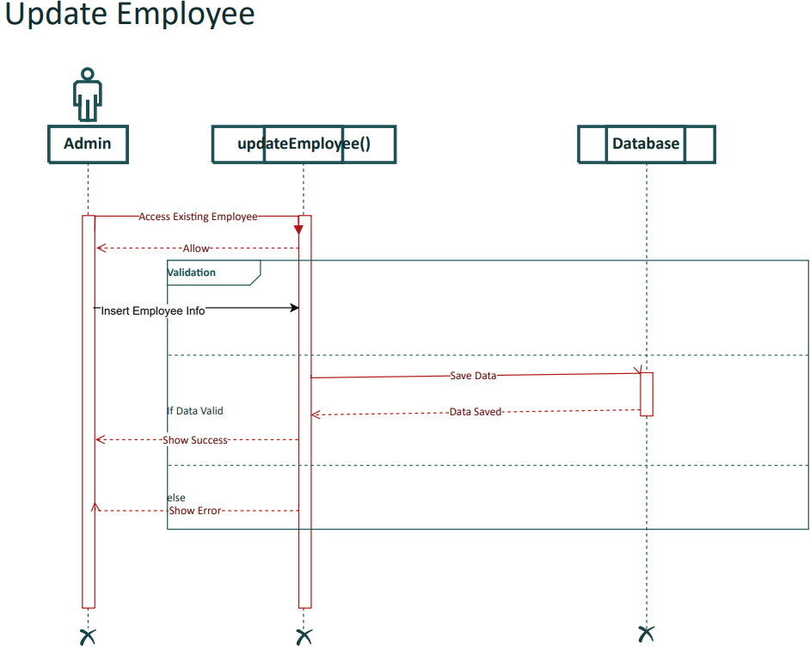

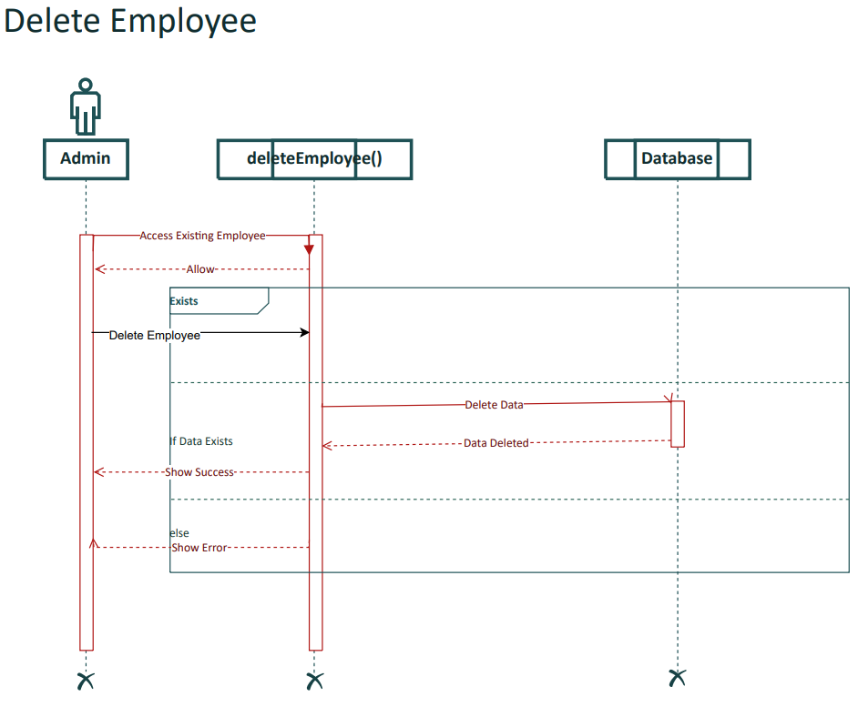 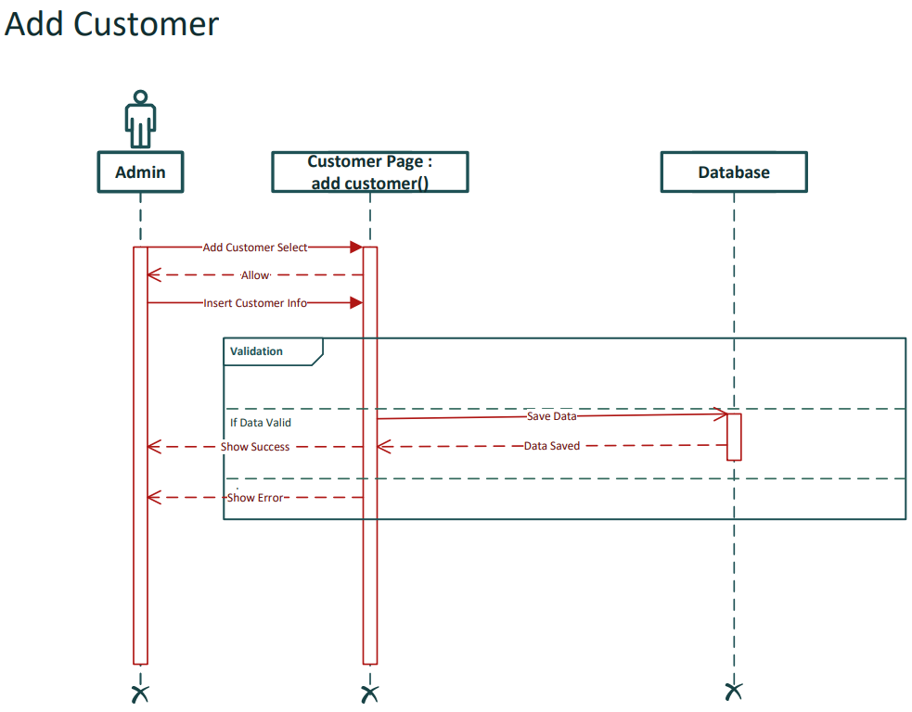 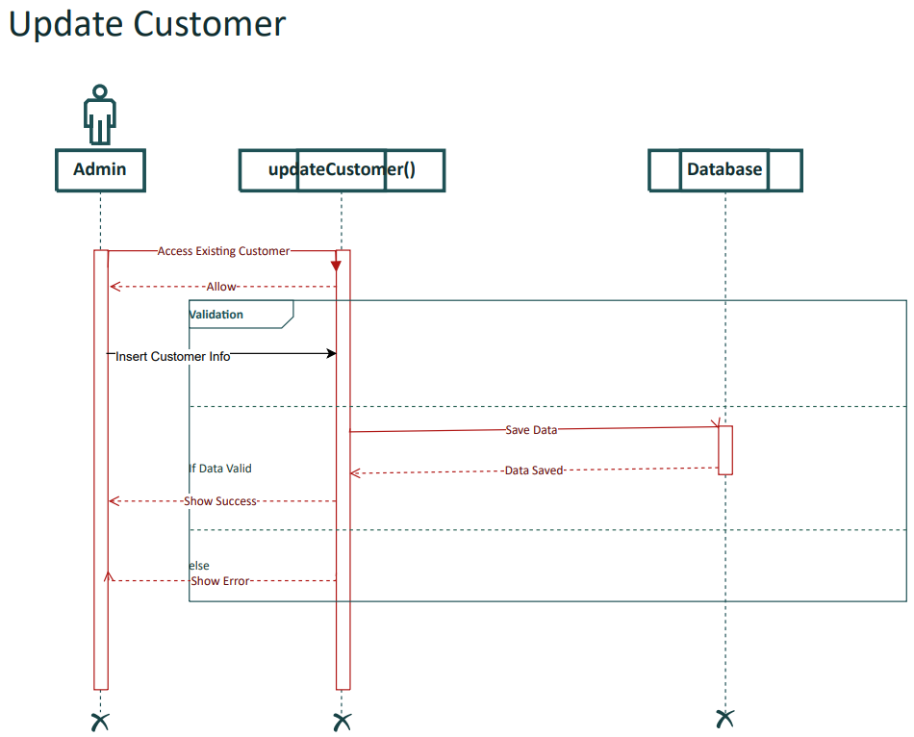

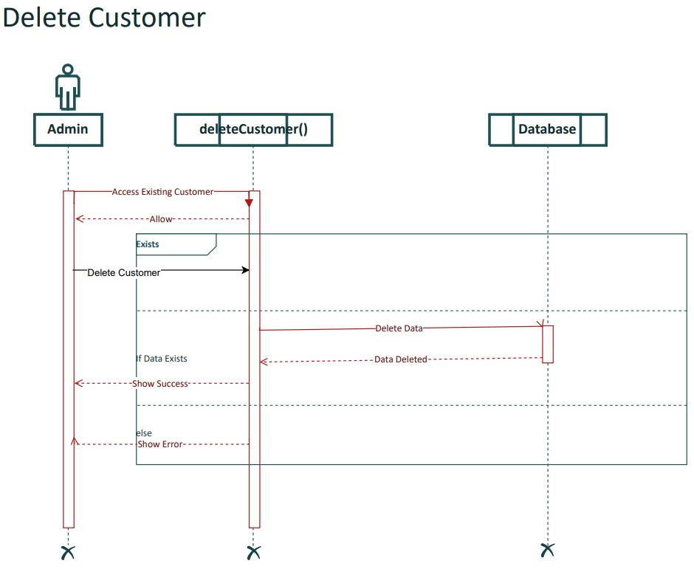

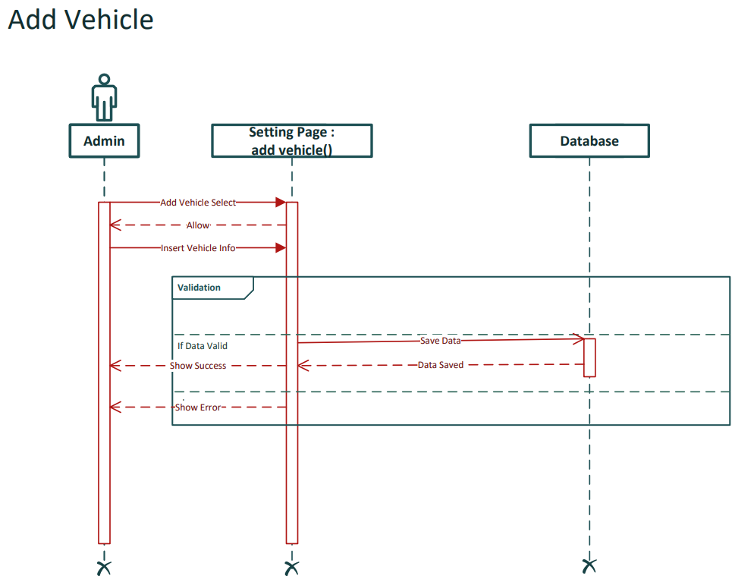 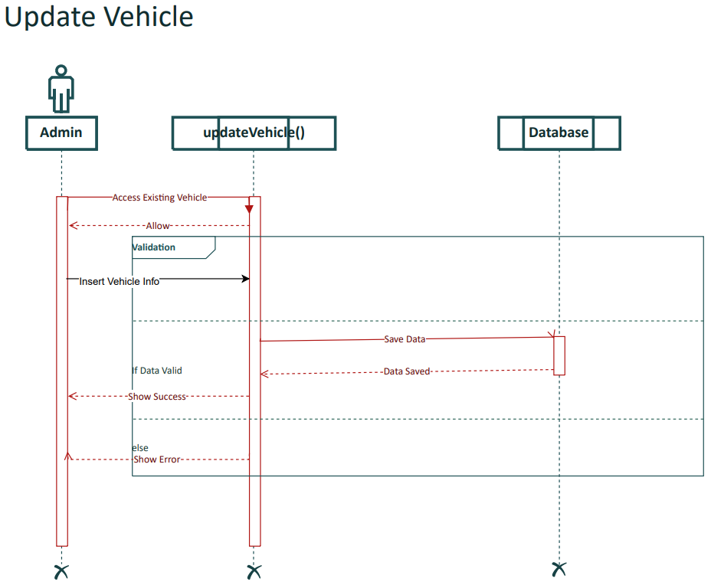

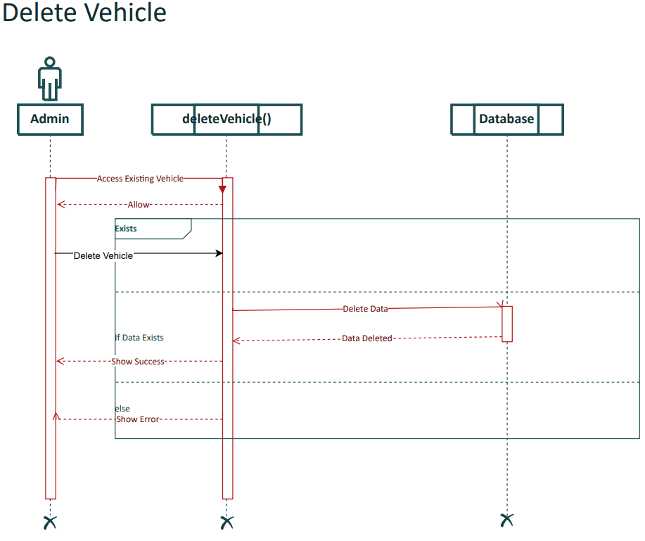

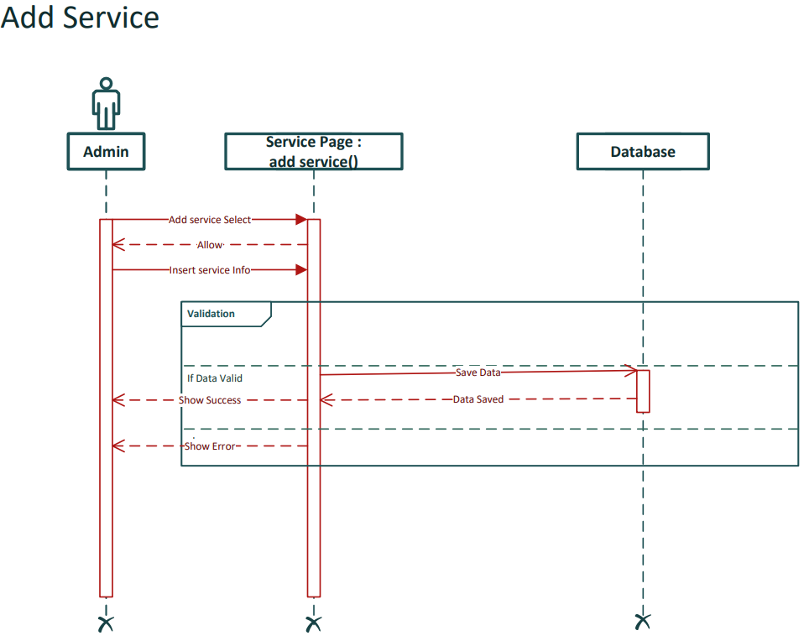 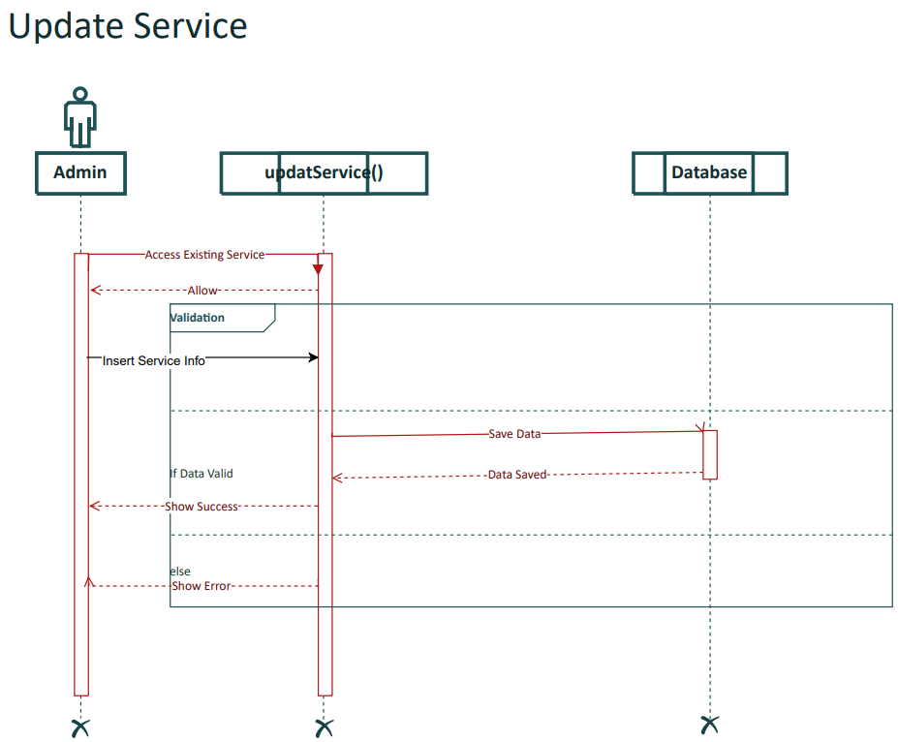 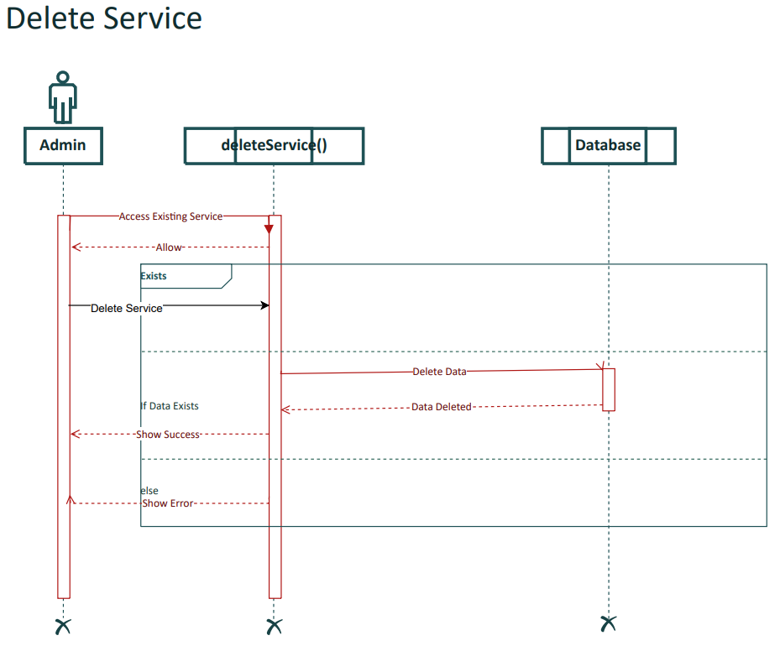 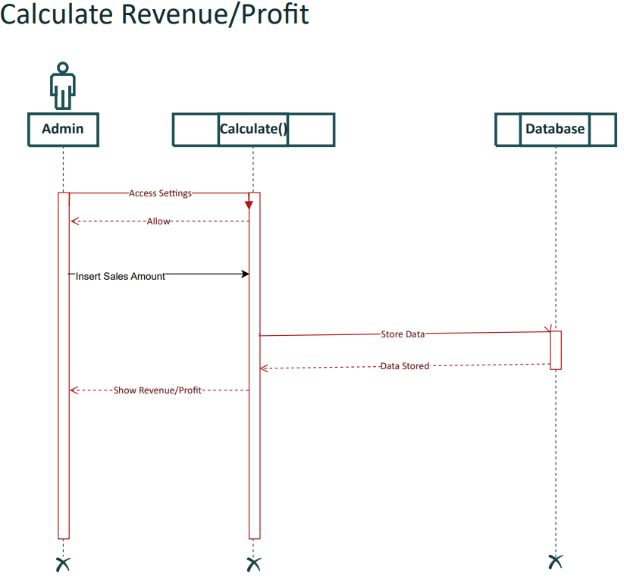 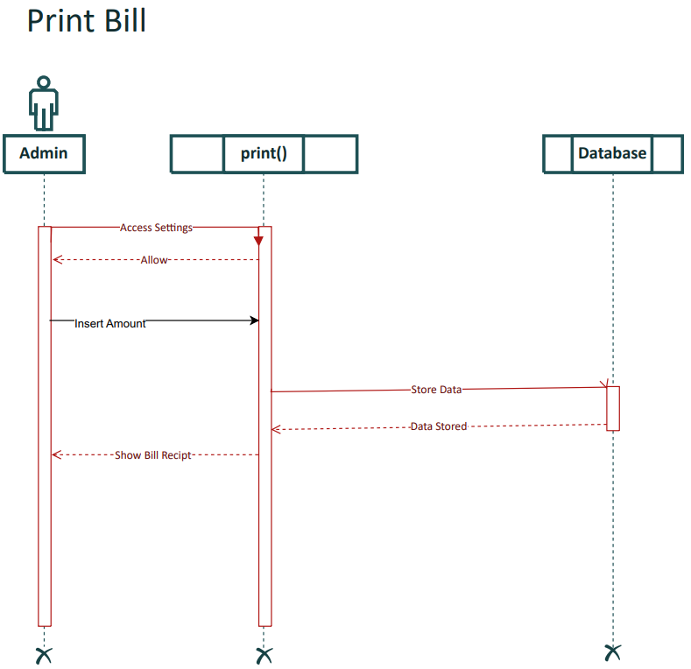 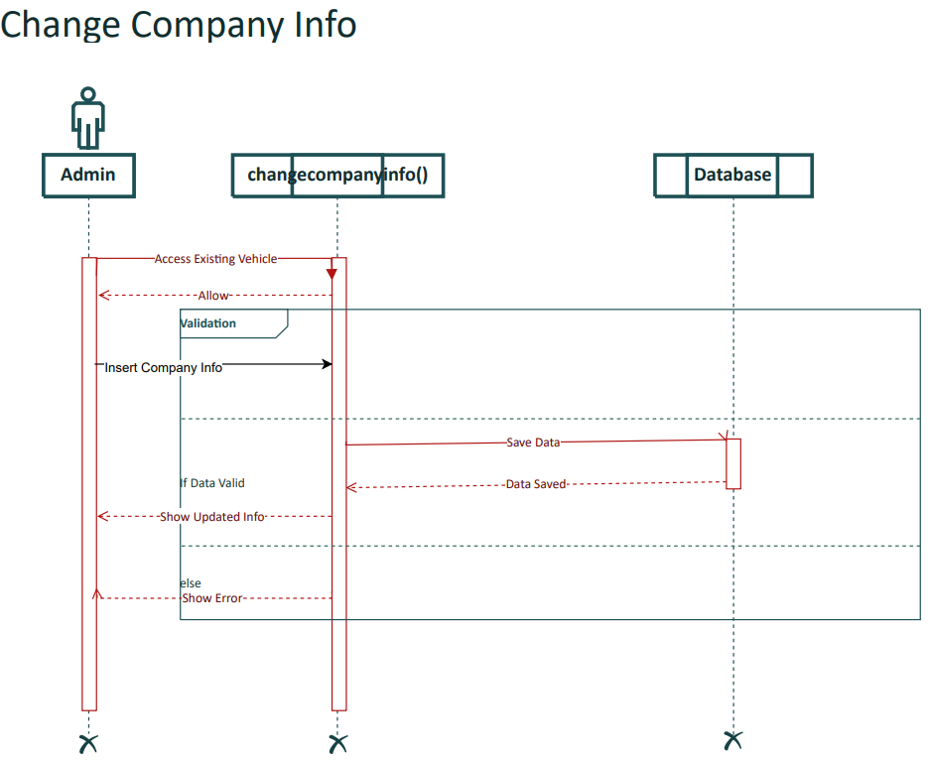

## Collaboration Diagram

* Sign In

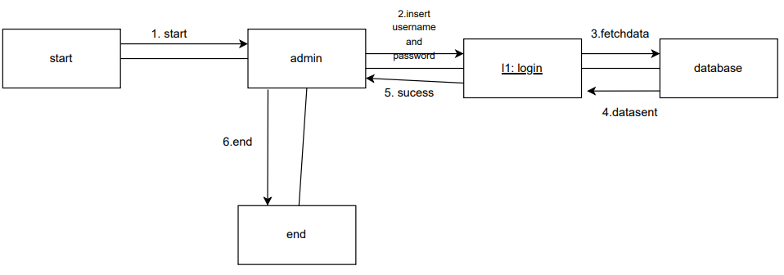

* Sign Up

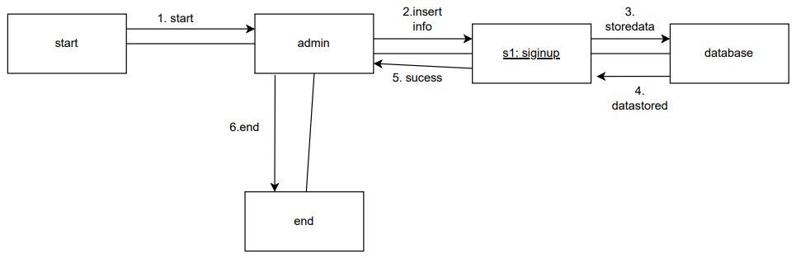

* Add Employee

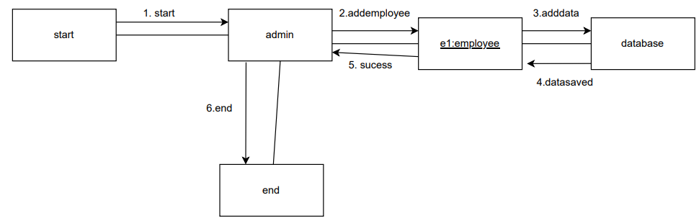

* Update Employee

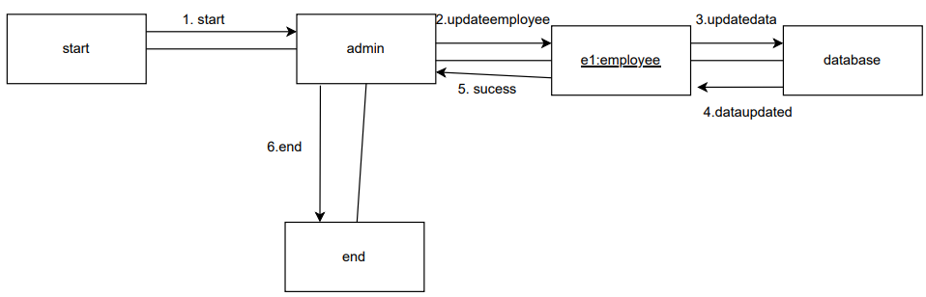

* Delete Employee

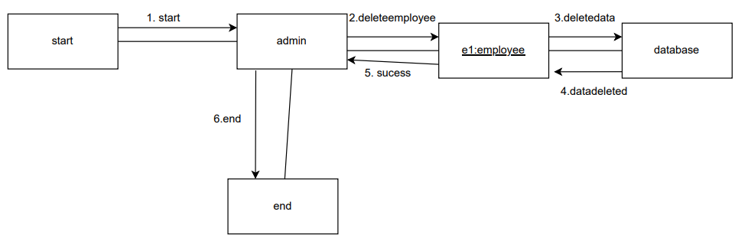

* Add Customer

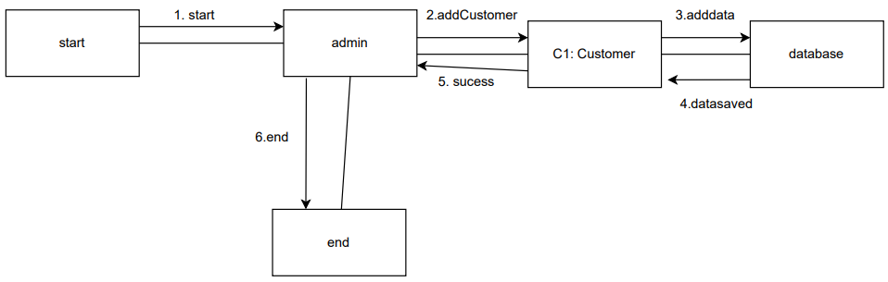

* Update Customer

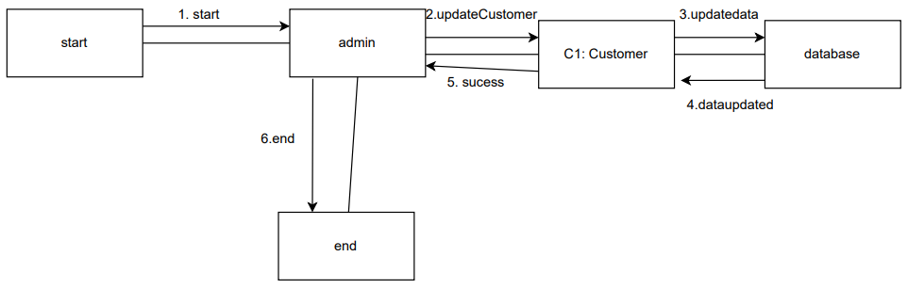

* Delete Customer

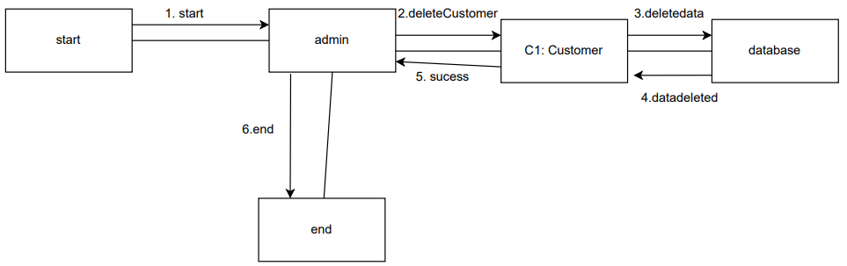

* Add Service

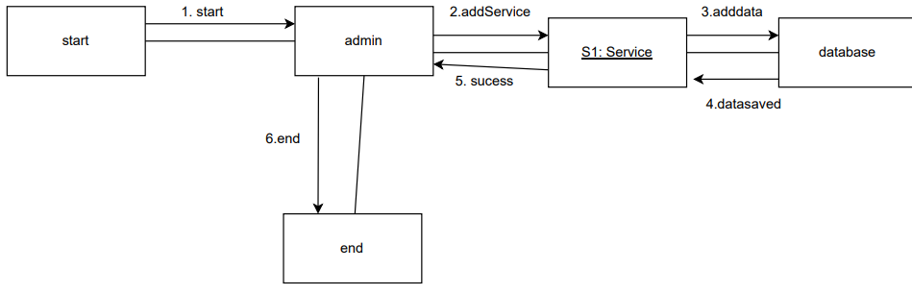

* Update Service

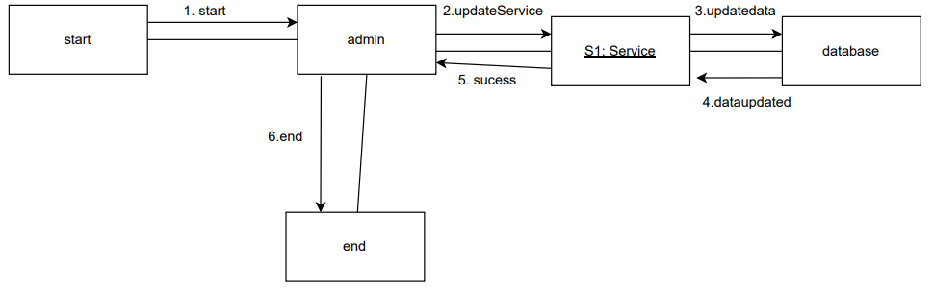

* Delete Service

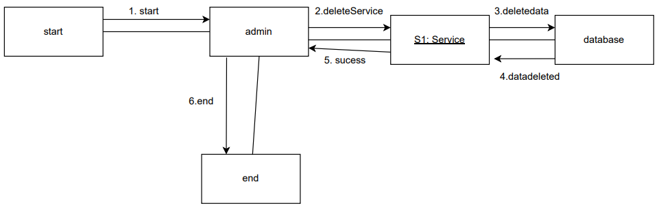

* Add Vehicle

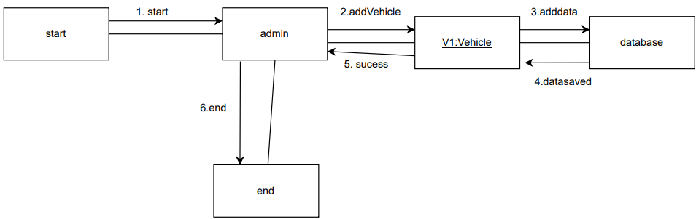

* Update Vehicle

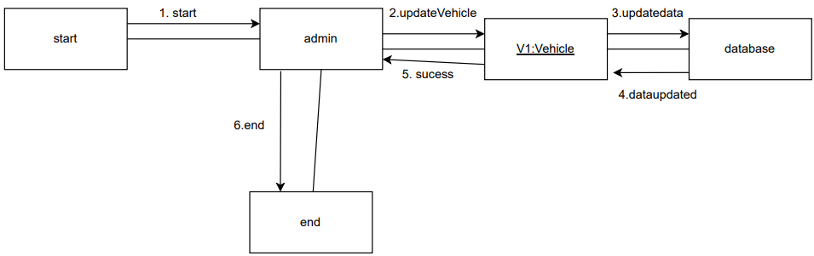

* Delete Vehicle

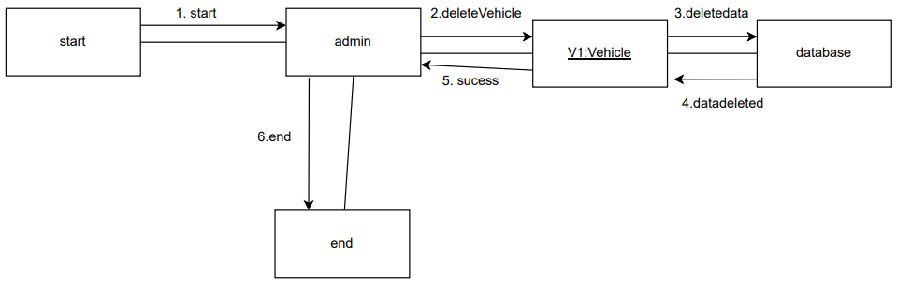

* Print Bill

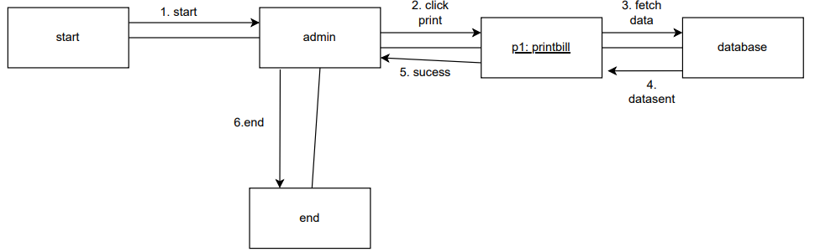

* Calculate Revenue/Profit

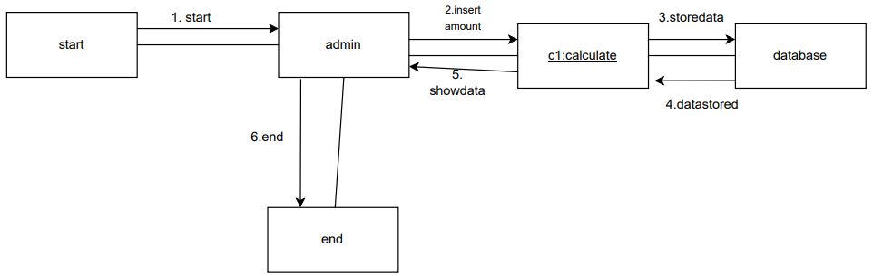

## Activity Diagram

* Sign In

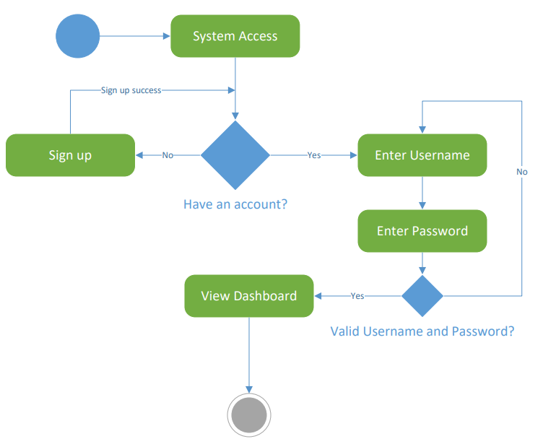

* Sign Up

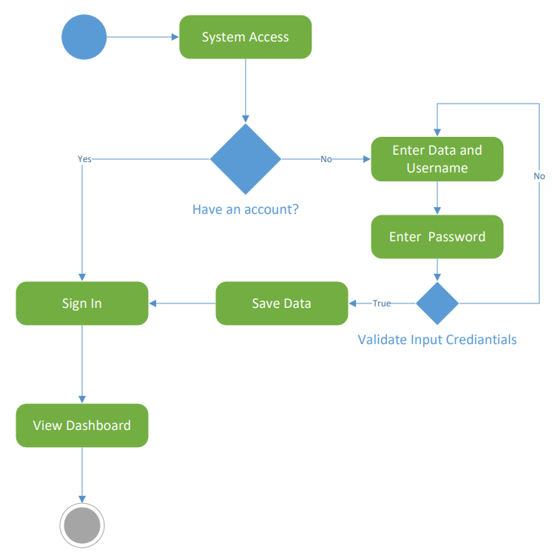

* Add Employee

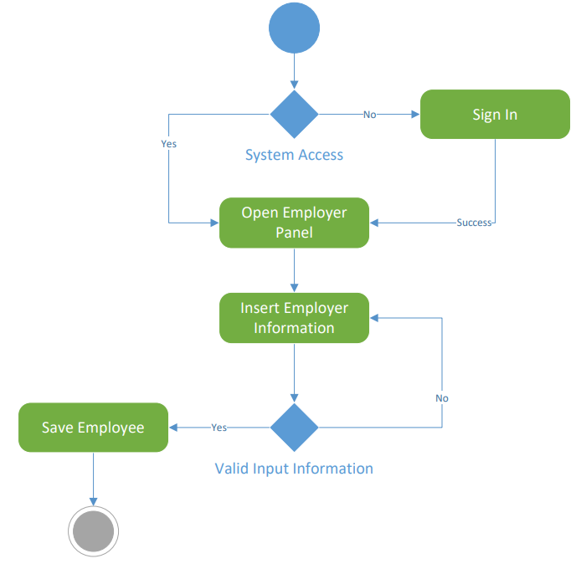

* Update Employee

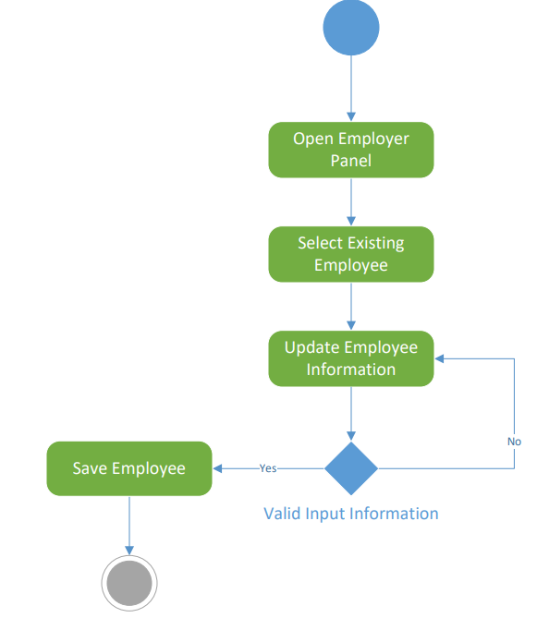

* Delete Employee

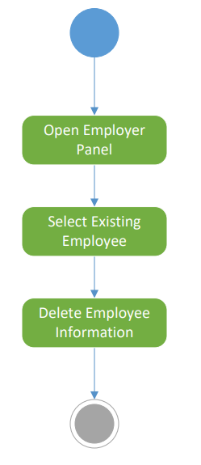

* Add Customer

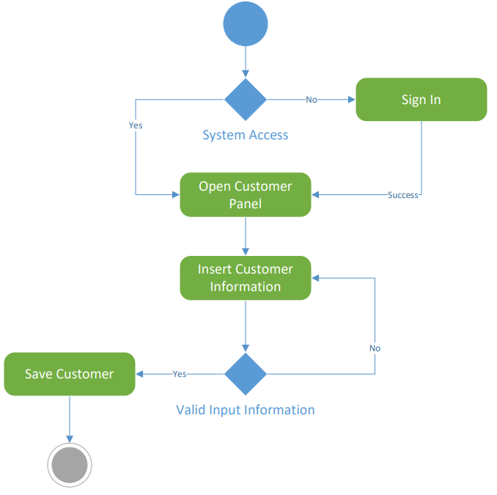

* Update Customer

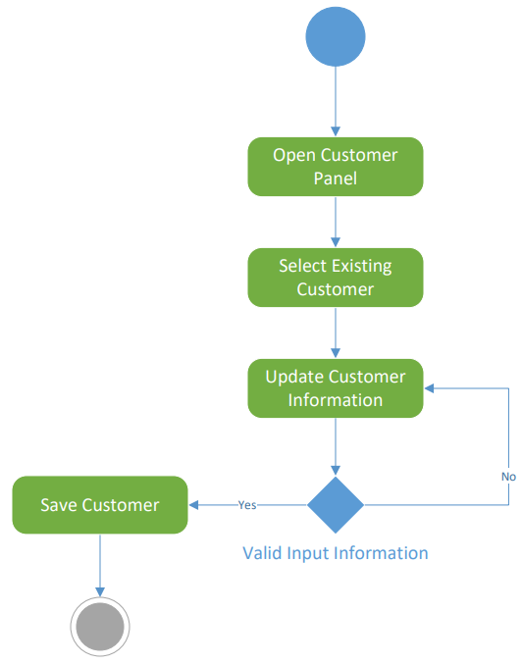

* Delete Customer

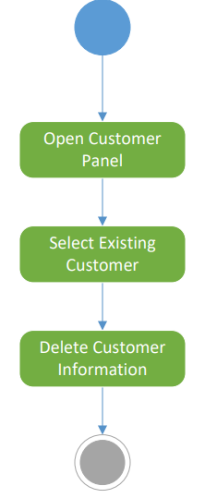

* Add Service

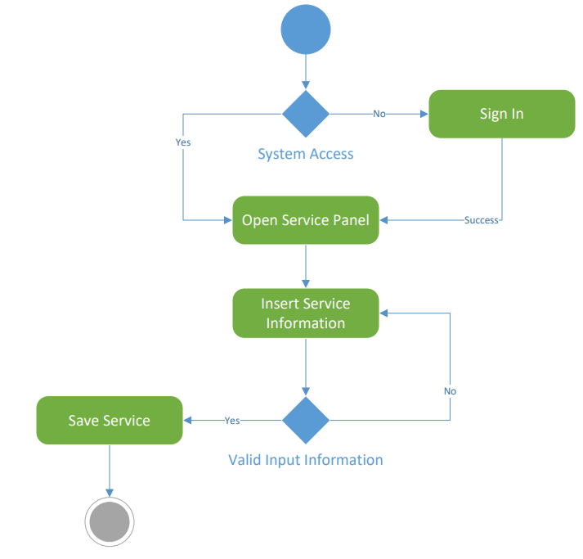

* Update Service

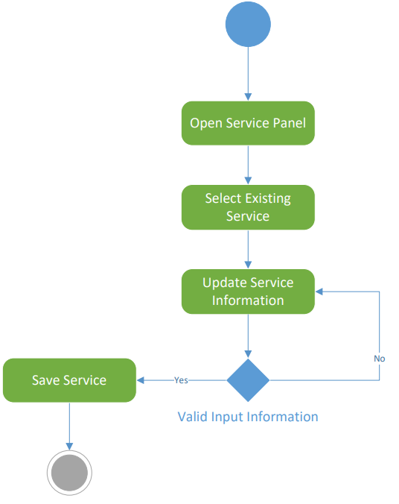

* Delete Service

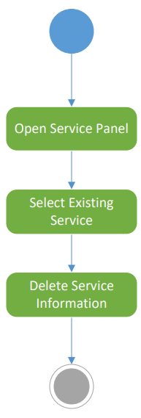

* Add Vehicle

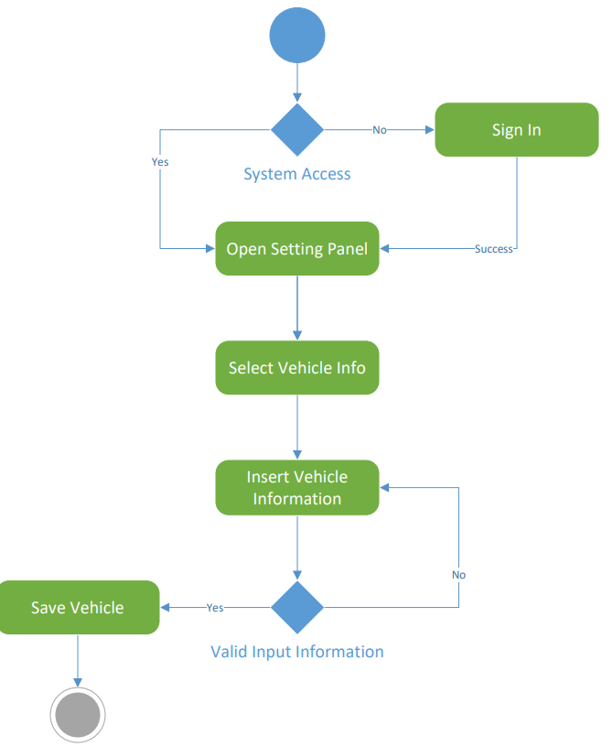

* Update Vehicle

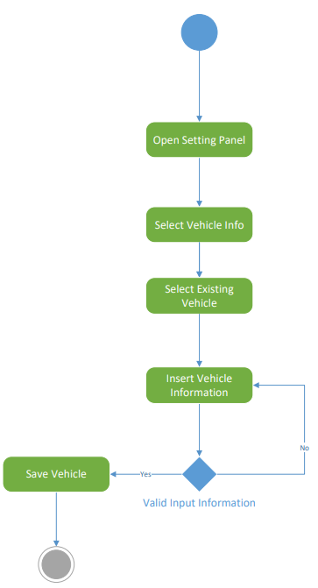

* Delete Vehicle

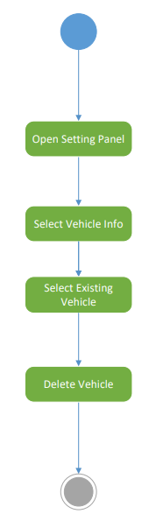

* Check Report

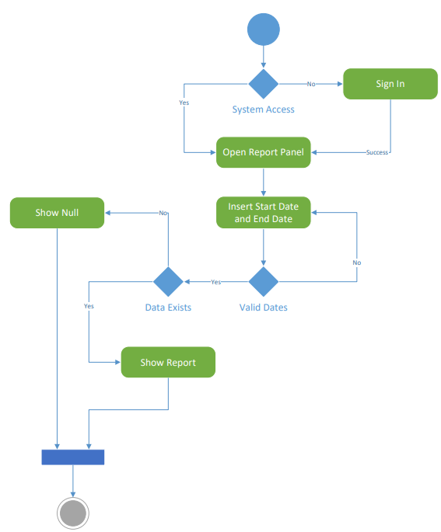

* Calculate Revenue/Profit

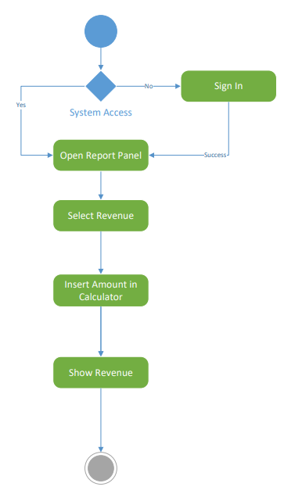

* Change Company Info

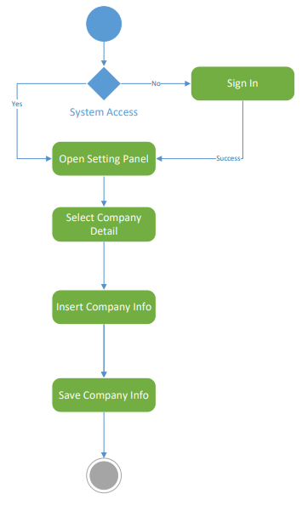

* Calculate Print Profit Receipt

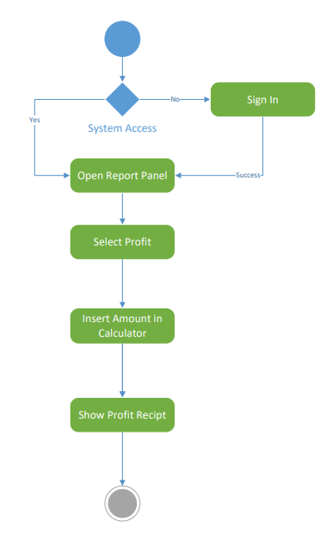

## State Machine Diagram

* Employee

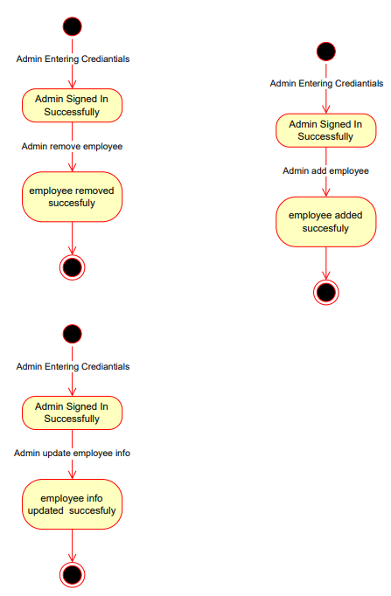

* Service

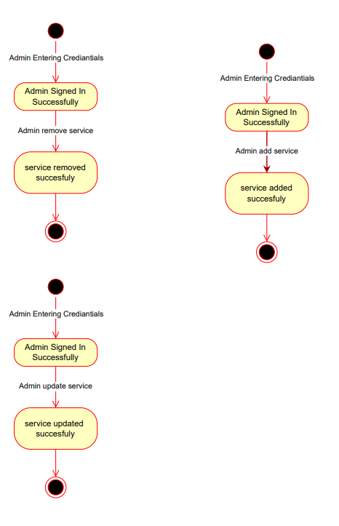

* Vehicle

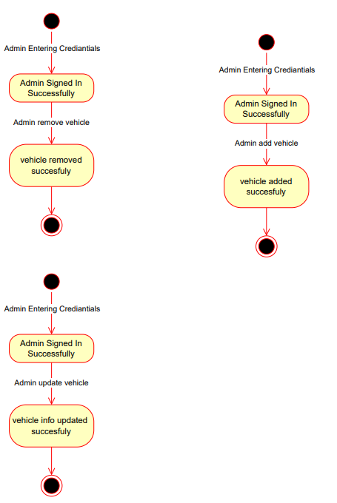

* Customer

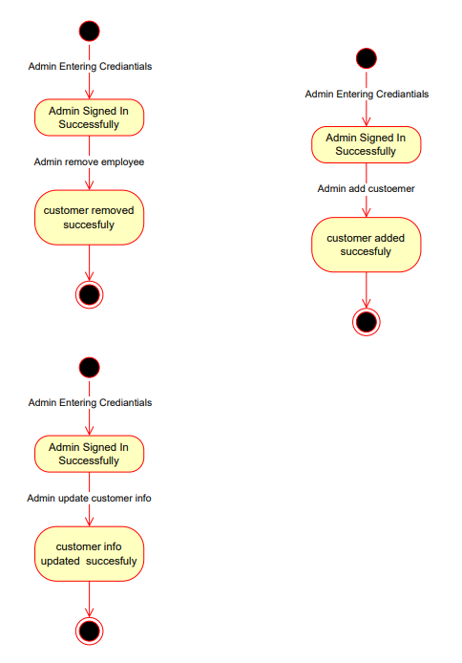

## Component Diagram

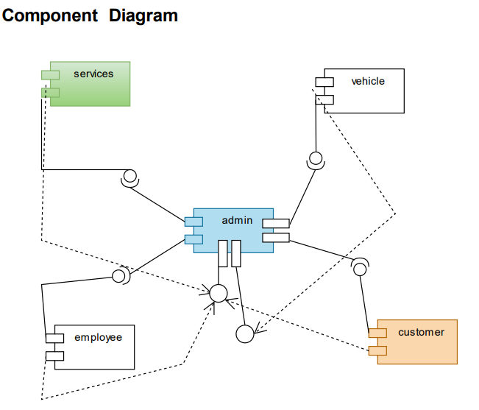

## Package Diagram

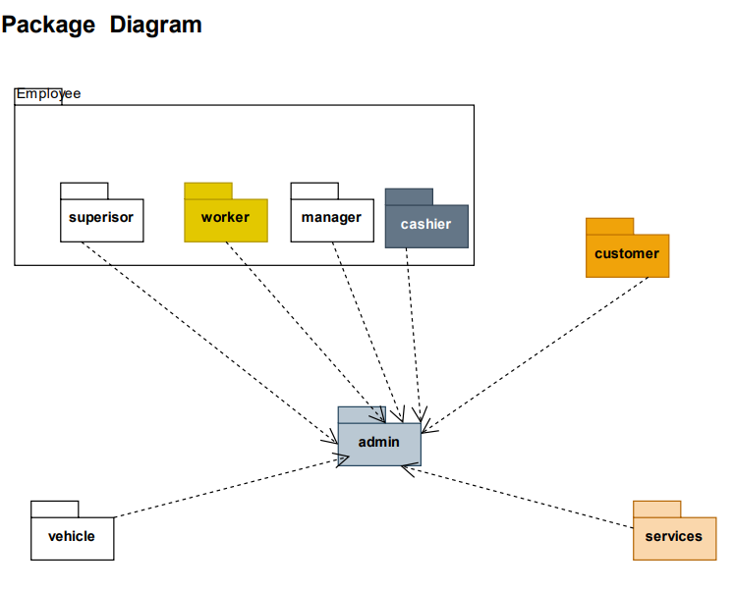

## Deployment Diagram

